2.2 In the Fig.2.2.1 the app ‘Blood Banks India Directory’ displays only the Blood Banks which helps the user to communicate with only blood bank but the user should allow to communicate with another user.[7] In the Fig.2.2.2 the app ‘Nepal Blood Donors’ requires email ID and the password or our Facebook account which loses security. Therefore our app allows user to create there new login details. This helps to maintain a security.[8]

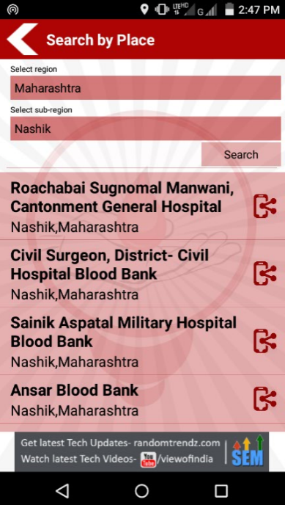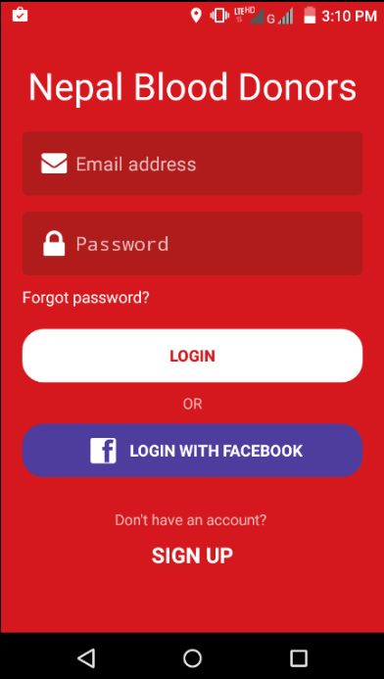

Fig.2.3: Screenshot of Blood Banks India Directory Fig.2.4: Screenshot of Nepal Blood Donors